Lab Blog Posts

Python Challenge

I went through the challenge struggling as at the time I was not too familiar with python and I had never done a digital abstract tests (challenges). I had to look up a lot of the solutions however, I was happy to understand new coding concepts and learn how to use urllibs.request properly. I also would attempt to come up with solutions myself using logical thinking. The earlier solutions were reasonably easy which is intentional as they provide a lot of hints to help introduce the developers to the challenge. A lot of the earlier challenges are somewhat recurring with a slightly increased difficulty.
The first challenge being a basic sequence that requires a transformation by 2 alphabetical spaces, they then tell you to use the maketrans() function.
In the following challenge it introduces you to looking at the page source for the coded challenge.
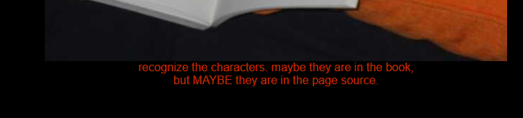
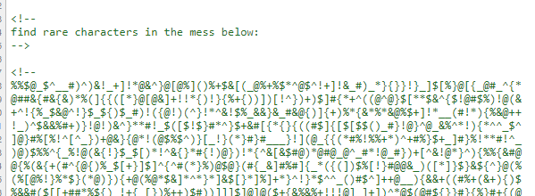
After we then use the html comments to mark out where we will be decoding the coded message which then printing out the re.findall() function to decipher the rare characters “t,i,u,e,l,y,q,a” which then will rewrite it into “equality”.
I progressed the following challenges in a similar pattern however, after half-way through I needed to rely more and more on external solutions.

Web Crawler

I set up the Crawler by setting up different areas of the application as shown in the source code, there is a separated file split up one managing the spiders and having them check different areas of the designated webpage. In this example I use my game development portfolio as my targeted website. With the target of the spider to build a new text file listing all of the links of the individual pages. As this is a very small website domain it does not require to queue the links for very long. However, the spiders are set up to push links from the queue into the crawled file allowing me to build up a small database of links connected to my homepage.
This could be used in a larger environment to collect all sorts of data, ranging from the usage of a certain number of quotes on a multitude of webpages which you could then feed this data into search engine application to consider what webpages would be more relevant to an individuals search.
I could also use this to extract information from websites of interest similar to how search engines use it, but I could create datasets instead for other processes such as machine learning.

Basic Neural Network
Neural Networks are a set of algorithms which have been designed to work loosely similar to the human brain. They get fed data into a model which then interprets the data’s patterns and then contain that pattern in a numerical vector format. These vectors can then be used in real-world data such as images, sound, and or text.
Neural Networks require a large amount of data and then a lot of training sessions or also known as an ‘epoch’ the more training the model does the higher the accuracy becomes which then can interpret and recreate new data based on the previously fed data sequences.
There are also different types of neural networks eg, Feedforward NN which is a model that is designed to pass different input nodes forwards until it reaches the output. This is a simpler variant which all data moves from input to output, unlike more complex neural networks that contain backpropagation.
I attempted to build a basic neural network model that is capable of learning about data provided to the model. I tested that the model was operational which worked fine. However, I had troubles getting the model to train and got an error I was not too sure how to fix.

Image Processing

I used what I had learnt prior with the Neural networks but worked closely to the Tensorflow example trying to understand how they set up their image processing I followed their route deconstructing bit by bit what they were doing and comparing this to how mick demonstrated it via GitHub.
I also attempted to comment the code where possible to help as a form of understanding from myself and so I could remember different code snippets I might want to come back too at a later date or reuse. In further project.
Image processing was fun as I could see a physical variable for a change rather than numbers and percentages. I got to see how a model could learn to interpret image data, I would like to deep dive more into TensorFlow's documentation to have a better overall understanding of machine learning models and how to build my own without assistance eventually.
This will be my new goal when it comes to machine learning is to gage a better understanding of how the models operate along with reading up more about the libraries and their functionality which then I could consider how to operate them to my advantages.

